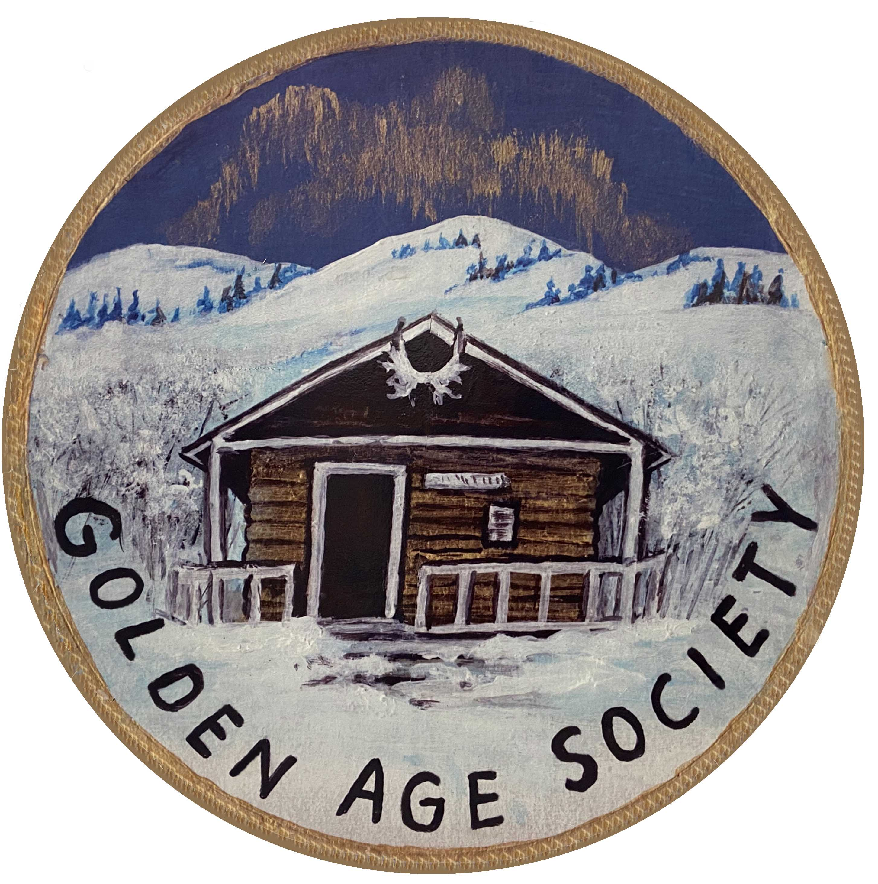

Customer Information Form
Internet Access Grant

Please fill out this form to receive an internet access grant.
(Please print.)

Name: ______________________________________________________________
Address: ____________________________________________________________
City or Town: _________________________ , Yukon Postal Code: Y__________
Telephone: _________________ E-mail: __________________________________
Monthly Grant Requested: ☑ Up to 3 months of receipt(s) attached: ☐
Installation Required? ☐ If the box at left is checked, please attach installation receipts.
Internet Connection Type: ☐ Cable ☐ Satellite ☐ Cell ☐ DSL ☐ Other: ____
Equipment Purchase: ☐ Laptop ☐ Desktop ☐ Tablet with Wi-Fi ☐ Cell with Wi-Fi
If a box in the line above is checked, please attach equipment receipts.
Chequing Account #: ____________________________ (for electronic funds transfer)
(Please provide a voided cheque if possible.)
Age: ☐ Over 55 years of age ☐ Under 55 years of age
How did you hear about this grant? ______________________________________

Note:
All personal information will be kept confidential. Aggregated information may be used for program evaluation and reporting purposes. Grant payments may be made using electronic funds transfer or by cheque. Each grant payment will be paid on receipt of proof of expenditures authorized under this program. Grants are subject to availability of funds.
I agree to these terms.

______________________________________ ___________________________
Signature Date

Working to prevent lung disease
Project Co-sponsor

____________________________________________________________________________
For office use only:
Request #: ________________ Internet Service Provider: ____________________________________________
Receipt Log:
Item # Description Amount Date Paid Comments

Customer Information Form
Internet Access Grant

For office use only:

Request #: ________________ Internet Service Provider: ____________________________________________

Receipt Log:
Item # Description Amount Date Paid Comments

____________________________________________________________________________________________

____________________________________________________________________________________________

____________________________________________________________________________________________

____________________________________________________________________________________________

____________________________________________________________________________________________

____________________________________________________________________________________________

____________________________________________________________________________________________

____________________________________________________________________________________________

____________________________________________________________________________________________

____________________________________________________________________________________________

____________________________________________________________________________________________

____________________________________________________________________________________________

____________________________________________________________________________________________

____________________________________________________________________________________________

____________________________________________________________________________________________

____________________________________________________________________________________________

____________________________________________________________________________________________

____________________________________________________________________________________________

____________________________________________________________________________________________

____________________________________________________________________________________________

____________________________________________________________________________________________

